**Component Name**: Voice command recognition

**Component Functionality**:

The main moto of this app is it transmit speech to text recognition. As soon as the page loads we display all the data in the form of data table. So, based on the click of mic icon user would be able to provide input so as to filter the data. And this filter happens through out all the fields in the table and also recognizes the digits and it’s been developed in react.

**Usage Areas**:

As it’s a reusable component can be used as a shared component wherever required.

**Component Technical details**:

* React version: 16.2.0
* Bootstrap version: 4.5.0

We have a single component with Web Speech Recognition Interface of Web Speech API library along with the datatable which is mocked to filter based on input provided and sort based on the columns provided by user.

**How this component can be integrated with other Applications**:

As it is a separate reusable component we need to import the same in our application wherever required to make use of the web speech API

**Screenshots**:

1. **Initial screen**: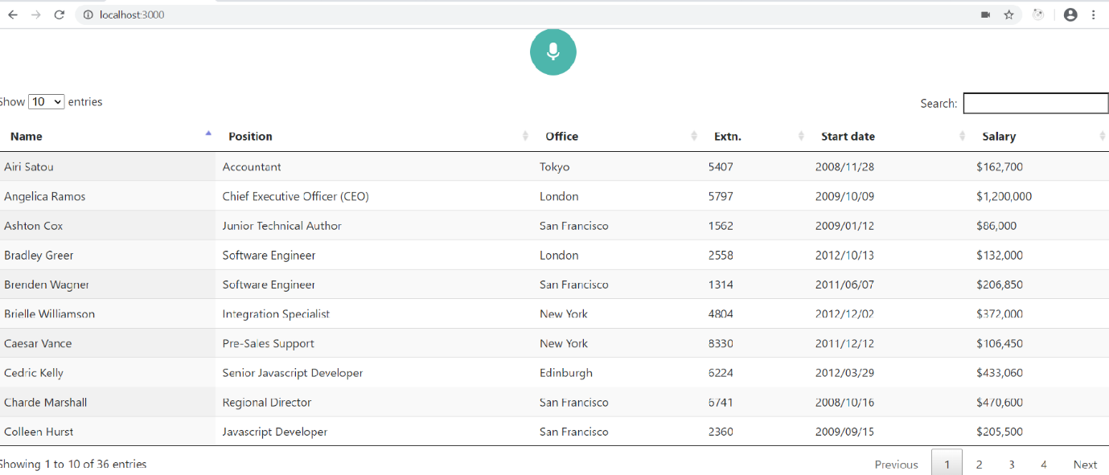
2. **When a user speaks, the text transmission happens and filters the data**

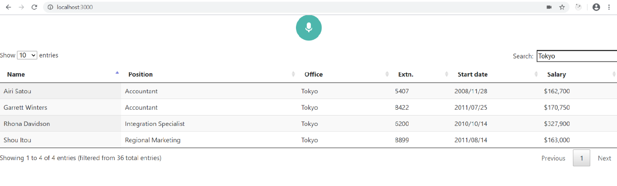

1. **Here, value is being matched with multiple columns through speech:**

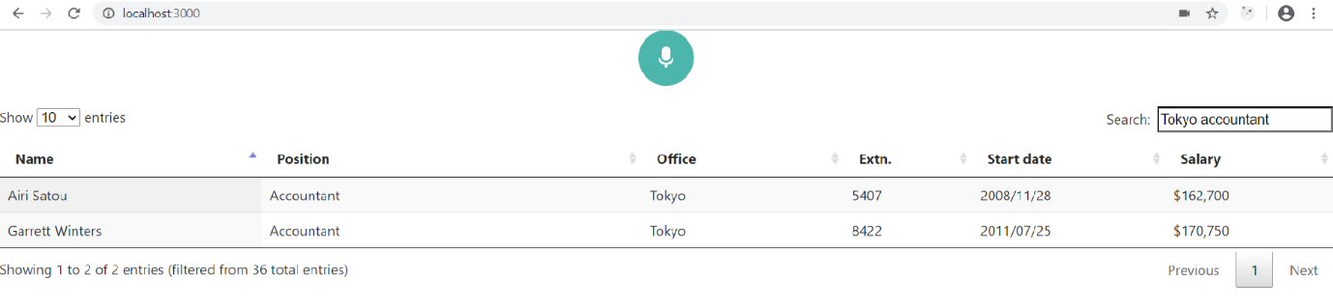

1. **Digits also transcript:**

